**About Flow Rule/Process Flow/Work Flow/Case/Transaction**

**Flow is a Process Rule**

**Flow is an instance of Rule-Obj-Flow**

**Purpose: To Define Life Cycle of the Business. Flow executes business transactions**.

* **A flow contains different flow shapes which are connected from start to end.**
* **A flow is a sequence of events that models a business process in your application. You create flows to support the different paths that users can take as they move a case through its life cycle.**
* **You can define paths in a flow by using graphical shapes and connectors. The shapes and settings that you choose depend on who performs each task, the types of decisions that users make, and order in which the events occur.**

**Flow shapes:**

**A shape in a flow represents a task that a user or application completes as part of a business process. By connecting different types of shapes in a flow, you can define the path that a case follows from creation to resolution.**

**Flow Shapes- 3 types**

1. **Basic Shapes**
2. **Advanced Shapes**
3. **Smart Shapes/Automation**

**Create a Flow Rule:**

**To Create a Flow -> Right Click on Process-> Flow**

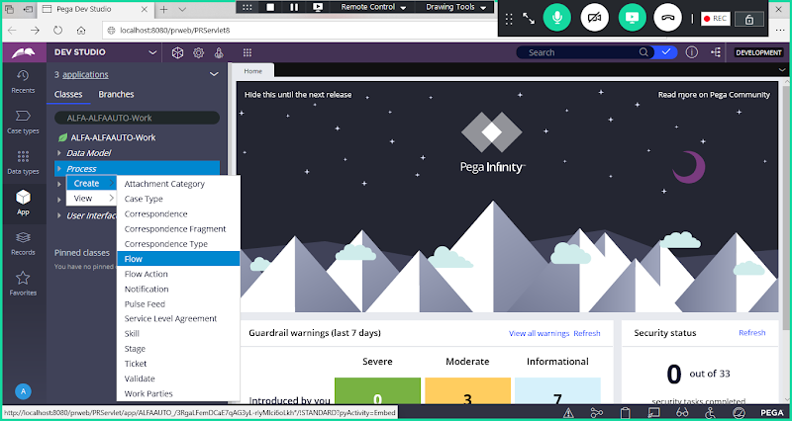

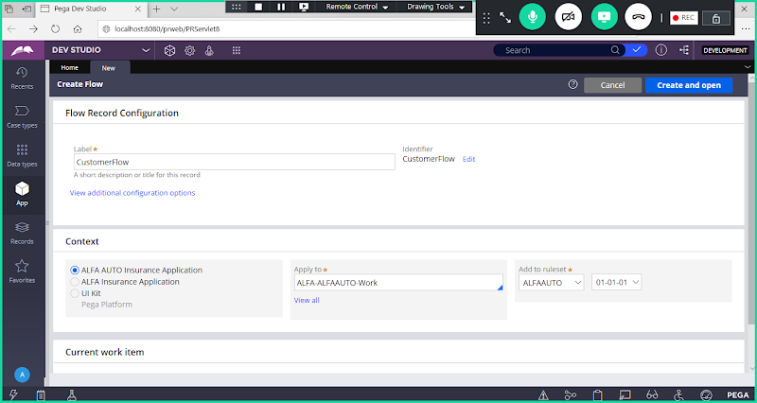

**Open**

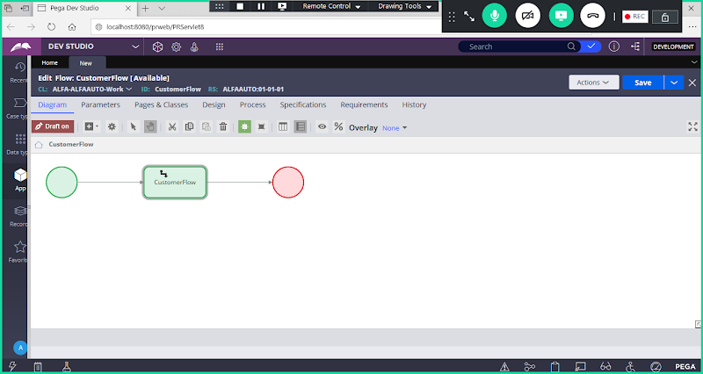

**Basic Shapes in Flow:**

**Start Shape: Begin the flow**

**Assignment Shape: used to Add Flowaction name( To Map UI Design)**

**End Shape: End the flow**

**Connector: Used to join shapes**

**How to Add Flowaction Rule in Flow:**

**Now add Flow action Name under Assignment shape Connector Properties:**

**Double Click on Assignment Connector settings:**

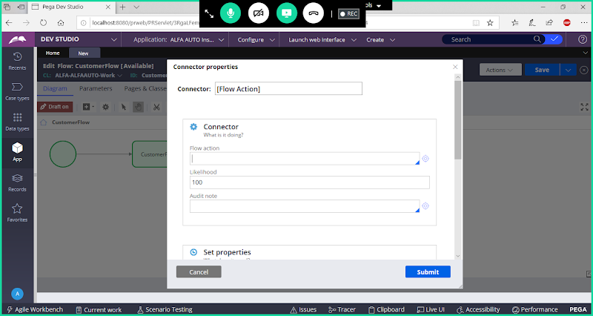

**In Dropdown select Flowaction Name**

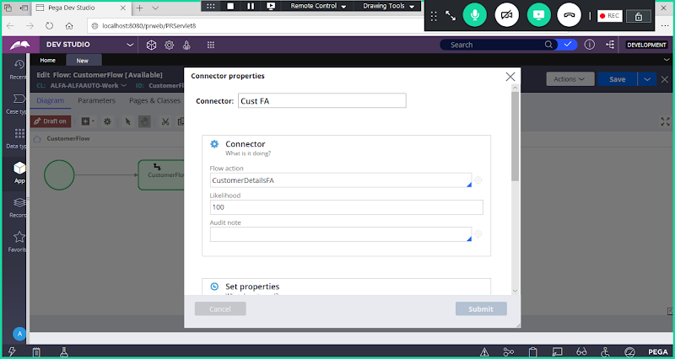

**Add Connector Label**



**Submit**

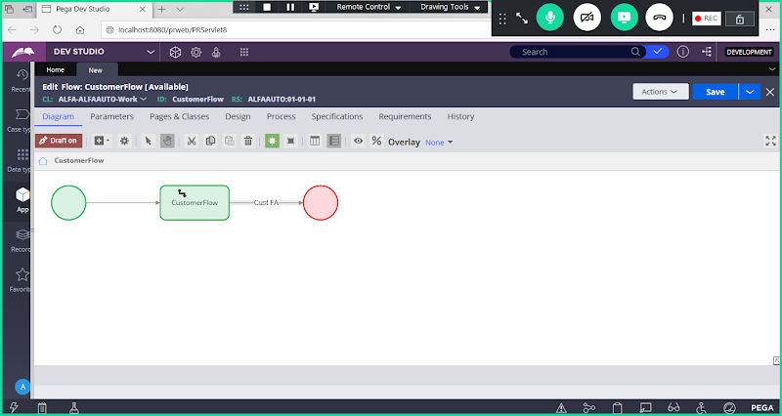

**Save Flow**

**Check the Warnings:**

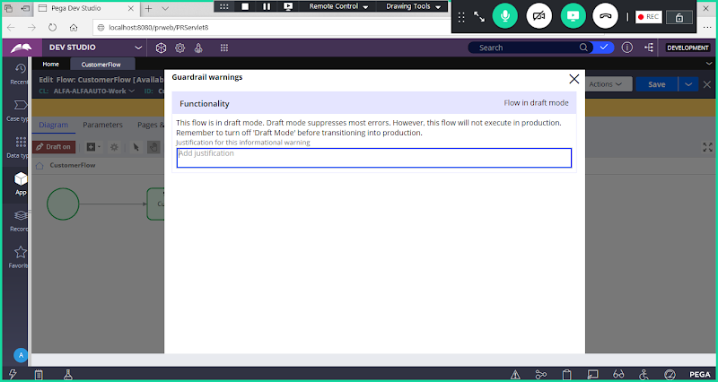

**Creating Work Object:**

**This flow is in draft mode. Draft mode suppresses most errors. However, this flow will not execute in production. Remember to turn off 'Draft Mode' before transitioning into production.**

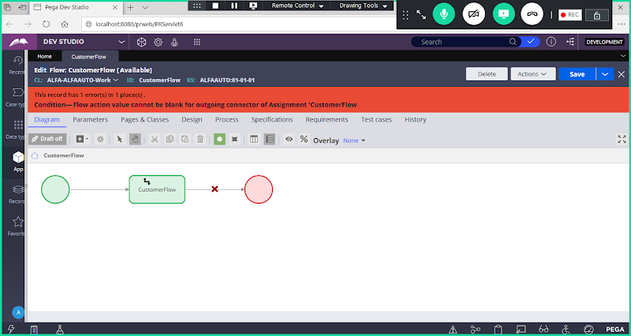

**Draft ON ( Default Mode):**

**For Every flow We have to Turn the Draft on to turn off Draft Flow**

**How to Turn off Draft Flow?**

**Ans:  Click on Draft ON Button**

**Draft On is a dummy Flow just for demonstration purpose. To execute our flows we have to click on Draft ON.**

**So Every flow we create we have to select : Draft ON**

**Now Try to Run the Flow from Actions Dropdown:**

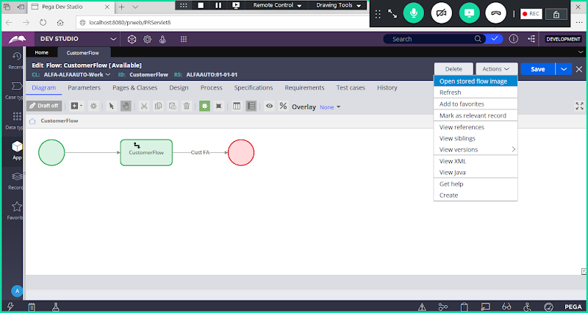

**There is No Run Option under Action Dropdown, because creates a new work object is not selected.**

**How to Make the Flow Executable:**

**Go to Process Tab of  Flow: To Enable Create a New Work Object:**

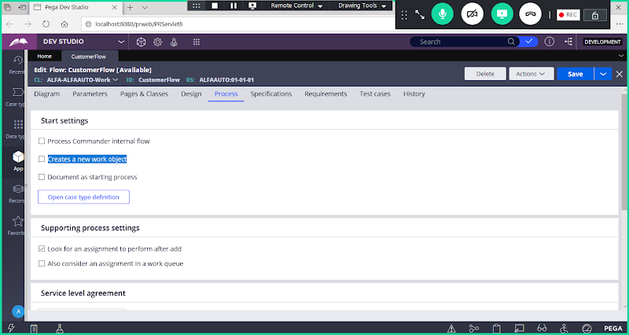

**Enable: Creates a New Work Object**

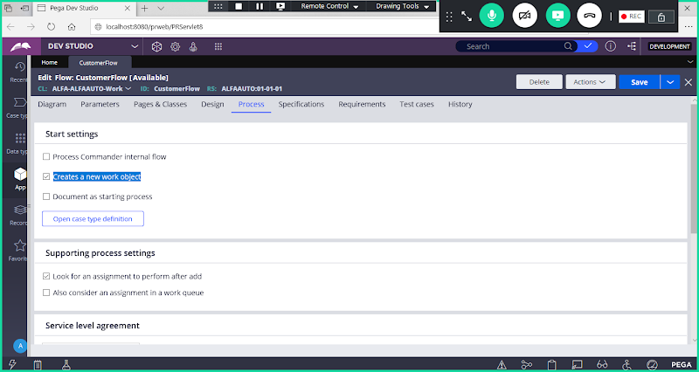

**Save Flow & Check Run Option under Action Dropdown**

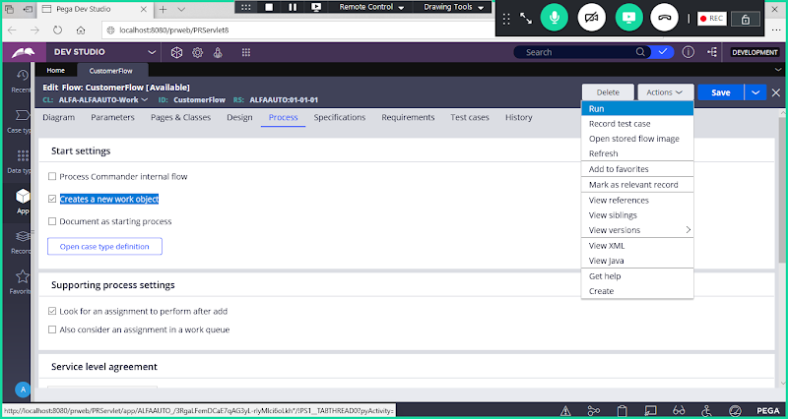

**Creates a New Work Object Option:**

**If Check box Not Selected:  Your Flow is Non-Executable flow ( No Run Under Action Dropdown)**

**If Check box Selected: Your Flow is Executable flow ( Run Under Action Dropdown)**

**After we Run the flow Default WorkParties Page will be Loaded. We need block the Page.**

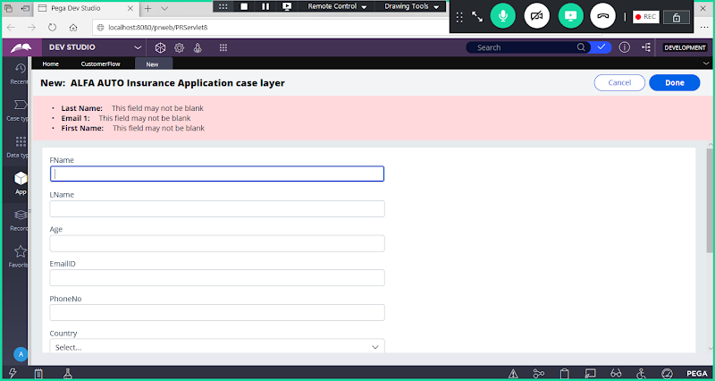

**After Loading above page we cannot move to next screen. SO, we have to block above work parties page.**

**Work Parties:  This Options is available under Process tab of Flow ( To go to this option scroll down)**

**How to Remove Default Work Parties Page:**

**Go to Process Tab of Flow:**

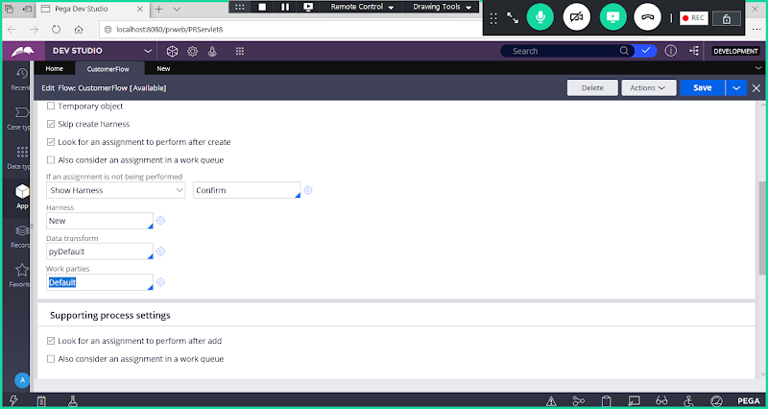

**You will have default option selected under Work Parties, Delete Default Option & Select pyCaseManagementDefault**

**Under Work Parties: Select pyCaseManagementDefault**

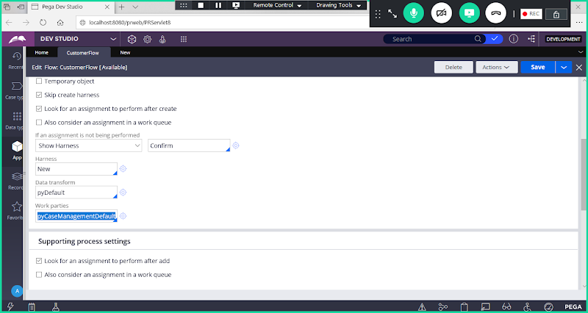

**Save the Flow**

**Execute Flow/ Compile Flow/Run the Flow**

**Actions-> Run**

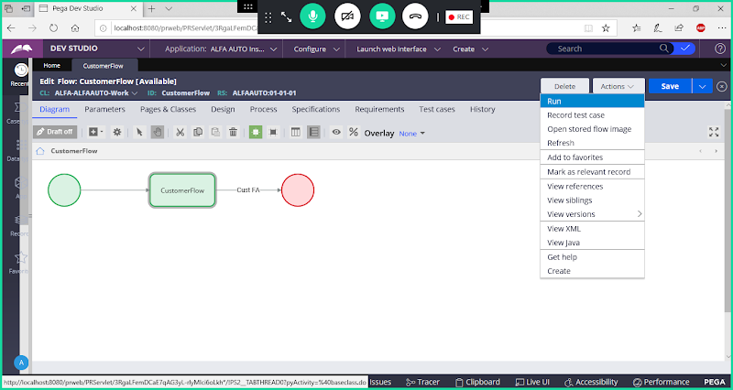

**Run Flow:**

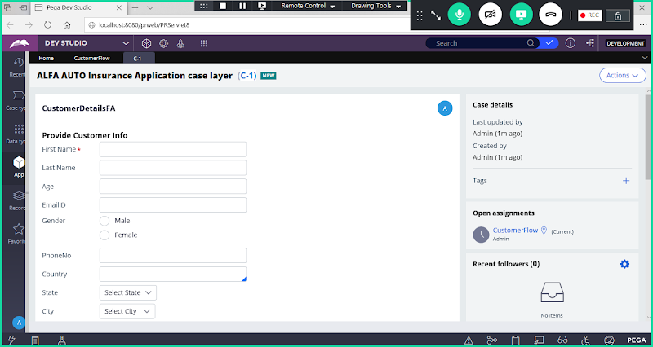

**For All the fields submit test Info.**

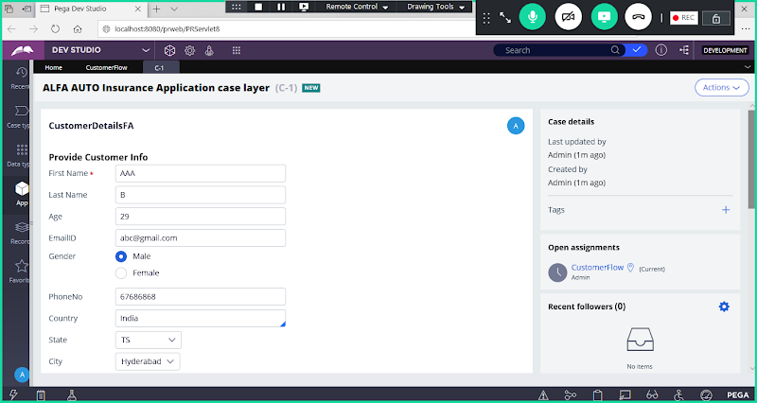

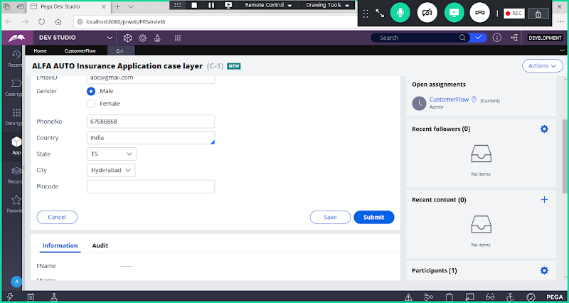

**Click on Submit**

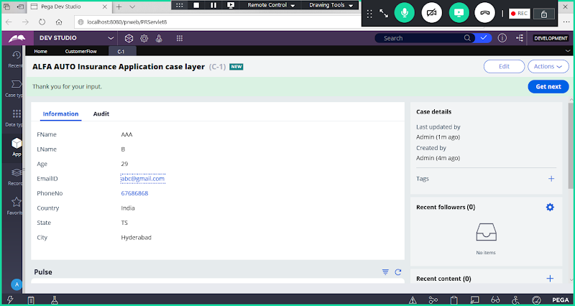

**When a Flow is executed it will create a work object in the background**

**==============**

**What is Work Object ?**

**After Execution the UI Form which loaded i.e workobject.**

**===**

**After Executing Flow & Submitting Work Object Data/Transaction data/ Case Information, it will create a Work Object ID.**

**Work Object ID = Case ID= Transaction ID= pyId= Thread**

**Note: When we run the flow, it creates a Work object ID. WO travels to the flow from start shape to end shape to complete the transaction.**

**WO ID: C-1**

**C- : Work ID  Prefix**

**1: Sequential No**

**====**

**Where Work Object Data/Case Information will be stored:**

**Ans: Data permanently will be stored in Rulebase/Server/PGAdmin4 Server**

**Where can we Check Transaction Data in the Rulebase:**

**Open Rulebase/PGAdmin4 Server:**

**Click on PGAdmin4.exe icon from Desktop**

**In Server Go to Below Path:**

**Servers-> LocalHost->Databases-> Postgres-> Schemas-> Data-> Tables**

**In the Rule Base when Application is defined Work Table/PC Table will be automatically created.**

**Work table Name: pc_alfa_alfaauto_work**

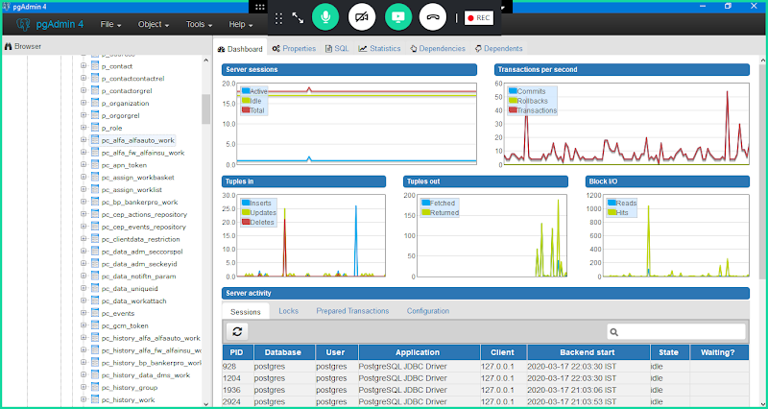

**Right Click Work Table-> View data -> View All Rows**

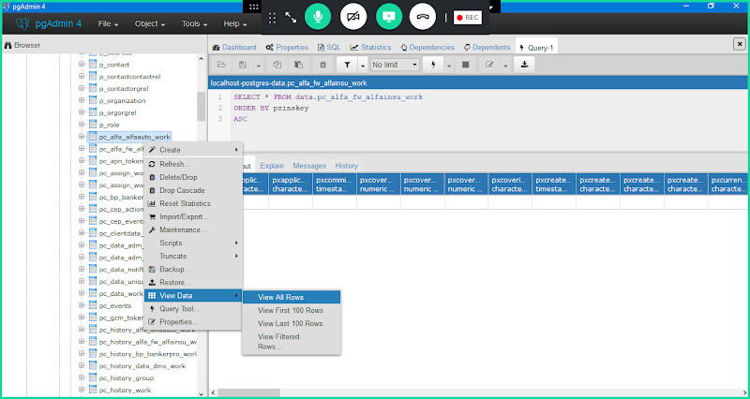

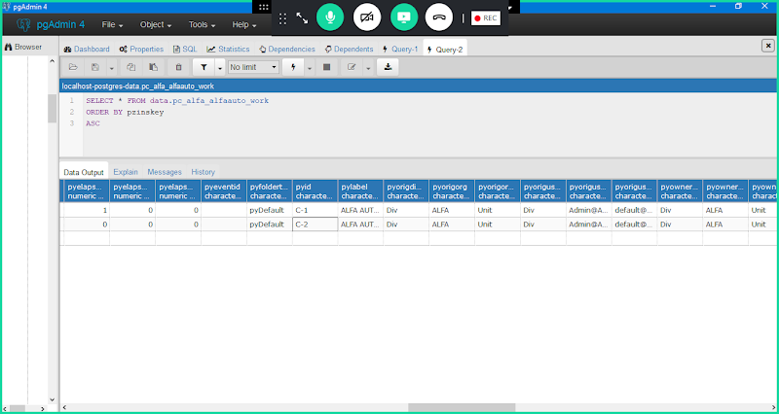

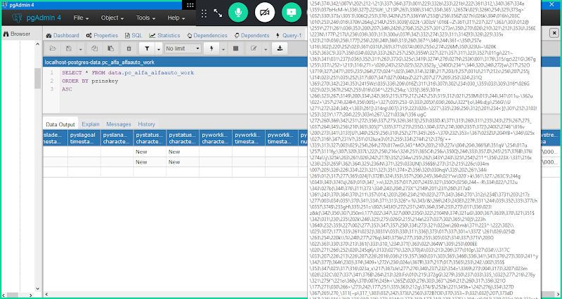

**Where WO Data Gets Stored in the rulebase?**

**It is Stored under Work Table(pc_alfa_alfaauto_work),  Inside Work Table under a Column pzpvstream in Binary/BLOB Format**

**Whatever the WO Data we submitted it will convert into diff format in a column ( pzpvstream) and saved in BLOB/Binary Format**

**UI --> XML/Page/Clipboard--> BLOB-> Data Table**

**=========================================**

**pzpvstream: U work Object Data will be stored to this Property**

**pyID**: **it is a unique identifier. Ur WO ID Value will be assigned to a Predefined property called pyID**

**=======**

**Where can we Create Work Object/ Execute the Flows**

**Work Object is an instance of Class group. Concrete class can have instances, but not abstract classes.**

**We can add Work Objects only under Concrete Class ( Is a Class group & Belongs to class group)- Keys( pyid) is defined only for Is a Class group & Belongs to Class group.**

**We Cannot add WO under abstract class & Data Classes & Int Classes.**

**We cannot add WO's under Doesn't belongs to Class group (Data Classes & Int Classes)**

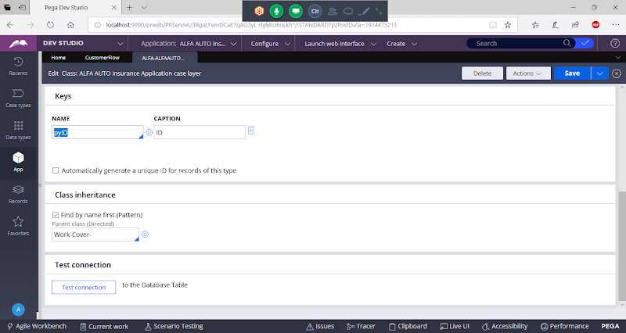

**==========**

**If we have Work Layer & Work Class ( Case Types) are there, can we create work objects under work layer?**

**A: We cannot create work objects under work layer, If we have case types/Work Classes then we cannot add work objects under work layer.**

**Work Layer ( Is a Class Group) :**

**If there are no case Types in our application then WO's can be created under Work Layer.**

**Work Class/Case Types( Belongs to Class Group)**

**If there are case Types in our application then WO's can be created under Work Class  Only ( Belongs to Class Group)**

**=======**

**In Flow: WO Data will Convert in XML Format/Page Format**

**In Clipboard: WO Data seen in Page Format( Physical Values)**

**In Rulebase/Server: WO data seen in BLOB Format**

**3 Types of Rule Base Tables we have in Rule Base:**

**pc Table/Work Table: Work Object data will be mapped**

**pr Tables: Data Tables / Data Types will be mapped**

**pr4 Tables: Business rules /PEGA Rules will be mapped**

**Any Business rule we add in the application it will be saved under pr4 table.**

**Note:  Any rule we create in the application including WO are instances of some concrete class( Doesn't Belongs to Class Grouo) i.e. all the rules & WO gets stored in to specific tables which are mapped to their instance classes.**

**Ex:**

**Property: Rule-Obj-Property-> PR4_Rule_Property**

**Section: Rule-html-section ->   PR4_Rule_Section**

**Flowaction: Rule-Obj-Flowaction -> PR4_Rule_Flowaction**

**Flow: Rule-Obj-Flow-> PR4_Rule_Flow**

**Class : Rule-Obj-Class -> PR4_Rule_Class**